Third Sunday of Advent
Bethlehem Lutheran Church
Sunday, December 11, 2022 – 10 a.m.
Traditional Worship

Welcome to All! We are glad that you are able to worship with us today. Please fill out a connection card in the pews if you like. During the service, we will sit or stand in reverence to our Lord. Please do what is physically comfortable and reverent for you. For those who are unable to receive Communion near the altar and wish to have the Pastor administer it at your seat, please obtain a red and white card from one of the ushers and hold it up at Communion time to alert the Pastor. If you or a little one would like to receive a blessing instead of Holy Communion, we invite you to come forward and cross your arms at the time of Communion. Please feel free to introduce yourself to our Pastor and fill out one of the Visitor cards available at our Welcome Table in the Gathering Place.

Evangelical Lutheran Worship – Setting 3, page 138

Pre-Worship Music/Announcements

Prelude

Lighting of the Advent Candle
Light One Candle to Watch for Messiah (3rd verse only, below) ELW 240
Light three candles to watch for Messiah: let the light banish darkness.
Lift your heads and lift high the gateway for the king of glory.

GATHERING

Confession and Forgiveness

P: Blessed be the Lord, the God of Israel, who alone does wondrous things. Blessed be God’s name forever.
C: Amen.

P: Beloved, now is the time to wake from sleep. Let us confront our sins,
and confess them to the one who is merciful and just.

Silence is kept for reflection.
P: God of new beginnings,
C: … we confess that we have not welcomed your holy reign. We have strayed from your paths. We prepare for war instead of peace.
We dishonor one another and your creation. Purify us with your refining fire and set us again on your way of love, that we may bear fruit worthy of repentance, and welcome your coming among us.
Amen.

P: People of God, a new thing is growing in our midst, a tender branch,
a living sign. By water and the Spirit you are joined to this wonder.
You have put on ☩ Christ, and your sins have been washed away. Rejoice in the way of the Lord.
C: Amen.

Gathering Hymn: Awake! Awake!, and Greet the New Morn ELW 242

Greeting

A: The grace of our Lord Jesus Christ, the love of God, and the communion of the Holy Spirit be with you all. C: And also with you.

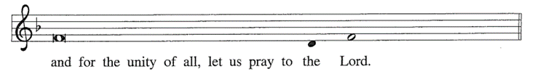
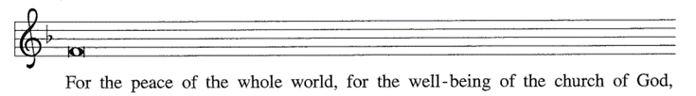
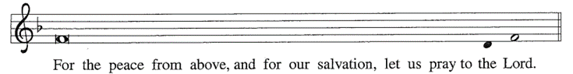
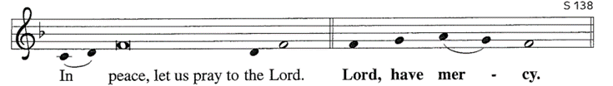
Kyrie (lead by Pastor Paul)
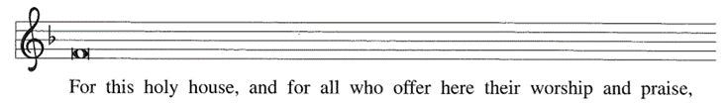

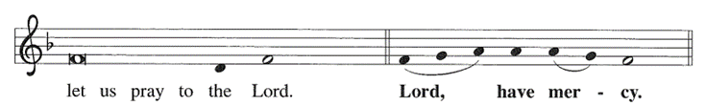
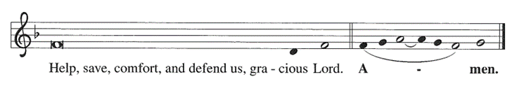

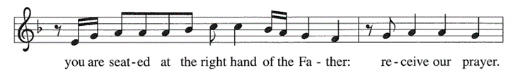
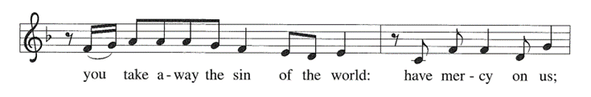
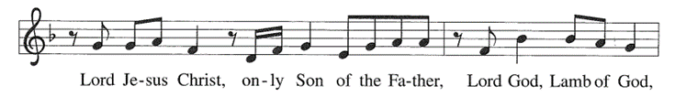
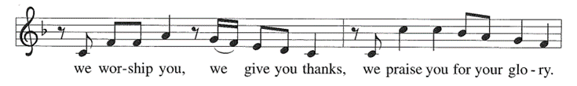
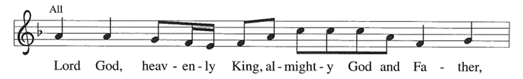
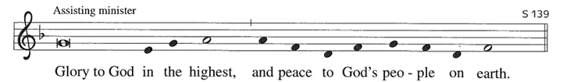
Hymn of Praise Glory to God

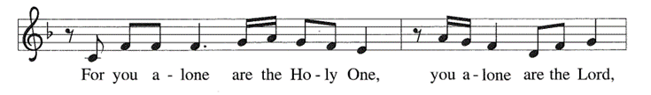
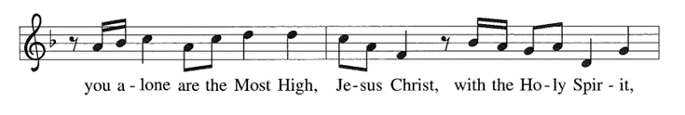
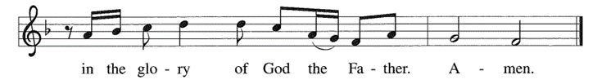

Prayer of the Day

A: Let us pray together…
C: Stir up the wills of all who look to you, Lord God, and strengthen our faith in your coming, that, transformed by grace, we may walk in your way; through Jesus Christ, our Savior and Lord, who lives and reigns with you and the Holy Spirit, one God, now and forever. Amen.

WORD

First Lesson Isaiah 35:1-10
The prophet describes the return from the Babylonian captivity as a joyous procession to Zion. God’s coming reign will bring a renewal of creation in which health and wholeness will be restored. There is no need for fear, for God is coming to save.

1The wilderness and the dry land shall be glad, the desert shall rejoice and blossom; like the crocus 2it shall blossom abundantly, and rejoice with joy and singing. The glory of Lebanon shall be given to it, the majesty of Carmel and Sharon. They shall see the glory of the Lord, the majesty of our God. 3Strengthen the weak hands, and make firm the feeble knees. 4Say to those who are of a fearful heart, “Be strong, do not fear! Here is your God. He will come with vengeance, with terrible recompense. He will come and save you.” 5Then the eyes of the blind shall be opened, and the ears of the deaf unstopped; 6then the lame shall leap like a deer, and the tongue of the speechless sing for joy. For waters shall break forth in the wilderness, and streams in the desert; 7the burning sand shall become a pool, and the thirsty ground springs of water; the haunt of jackals shall become a swamp, the grass shall become reeds and rushes. 8A highway shall be there, and it shall be called the Holy Way; the unclean shall not travel on it, but it shall be for God’s people; no traveler, not even fools, shall go astray. 9No lion shall be there, nor shall any ravenous beast come up on it; they shall not be found there, but the redeemed shall walk there.
10And the ransomed of the Lord shall return, and come to Zion with singing;
everlasting joy shall be upon their heads; they shall obtain joy and gladness,
and sorrow and sighing shall flee away.

L: The Word of the Lord.
C: Thanks be to God.

Psalmody Psalm 146:5-10

5Happy are they who have the God of Jacob for their help, whose hope is in the Lord their God;
6who made heaven and earth, the seas, and all that is in them; who keeps promises forever;

7who gives justice to those who are oppressed, and food to those who hunger.
The Lord sets the captive free.
8The Lord opens the eyes of the blind; the Lord lifts up those who are bowed down; the Lord loves the righteous.

9The Lord cares for the stranger; the Lord sustains the orphan and widow, but frustrates the way of the wicked.
10The Lord shall reign forever, your God, O Zion, throughout all generations. Hallelujah!

Second Lesson James 5:7-10
In anticipation of the Lord’s coming, Christians are called upon to cultivate patience rather than discontent.

7Be patient, therefore, beloved, until the coming of the Lord. The farmer waits for the precious crop from the earth, being patient with it until it receives the early and the late rains. 8You also must be patient. Strengthen your hearts, for the coming of the Lord is near. 9Beloved, do not grumble against one another, so that you may not be judged. See, the Judge is standing at the doors! 10As an example of suffering and patience, beloved, take the prophets who spoke in the name of the Lord.

L: The Word of the Lord.
C: Thanks be to God.

Gospel Acclamation Alleluia

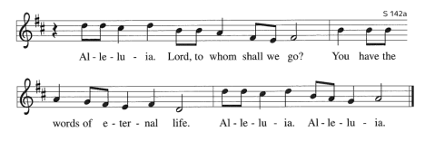

Gospel Matthew 11:2-11

John the Baptist expects the Messiah to bring God’s judgment upon the earth (Matt. 3:11-12). From a prison cell, he wonders whether Jesus is the one who will do this. Jesus’ response indicates that God’s reign is indeed being fulfilled already through healing and restoration.

C: …Glory to you, O Lord…

2When John heard in prison what the Messiah was doing, he sent word by his disciples 3and said to him, “Are you the one who is to come, or are we to wait for another?” 4Jesus answered them, “Go and tell John what you hear and see: 5the blind receive their sight, the lame walk, the lepers are cleansed, the deaf hear, the dead are raised, and the poor have good news brought to them. 6And blessed is anyone who takes no offense at me.” 7As they went away, Jesus began to speak to the crowds about John: “What did you go out into the wilderness to look at? A reed shaken by the wind? 8What then did you go out to see? Someone dressed in soft robes? Look, those who wear soft robes are in royal palaces. 9What then did you go out to see? A prophet? Yes, I tell you, and more than a prophet. 10This is the one about whom it is written, ‘See, I am sending my messenger ahead of you, who will prepare your way before you.’ 11Truly I tell you, among those born of women no one has arisen greater than John the Baptist; yet the least in the kingdom of heaven is greater than he.”

P: The Gospel of the Lord.
C: Praise to you, O Christ.

Sermon Pastor Paul Busekist

Hymn of the Day All Earth Is Hopeful ELW 266

Apostle’s Creed

I believe in God, the Father almighty, creator of heaven and earth.

I believe in Jesus Christ, God’s only Son, our Lord, who was conceived by the Holy Spirit, born of the virgin Mary, suffered under Pontius Pilate, was crucified, died, and was buried; he descended to the dead. On the third day he rose again; he ascended into heaven, he is seated at the right hand of the Father, and he will come to judge the living and the dead.

I believe in the Holy Spirit, the holy catholic church, the communion of saints, the forgiveness of sins, the resurrection of the body, and the life everlasting. Amen.

Prayers of Intercession: response after each petition: “Hear our prayer.” (Before prayer) A: As we prepare for the fullness of Christ’s presence, let us pray for a world that yearns for new hope. (Conclusion) P: God of our longing, you know our deepest needs. By your Spirit, gather our prayers and join them with the prayers of all your children. In Jesus’ name we pray.
C: Amen.

Sharing of the Peace (Let us give one another a sign of peace according to your comfort level.)
P: The peace of Christ be with you always.
C: And also with you.
MEAL

Offering (Please be seated.)

Offering Song: Zeke Clemons

Offertory (Please stand, as able.) Let the Vineyards Be Fruitful
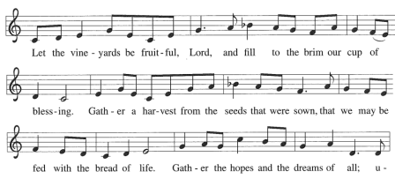
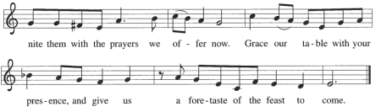
Offering Prayer

A: Let us pray.
C: Eternal God, you make the desert bloom and send springs of water to thirsty ground. Receive these simple gifts of bread, wine, and money, and make us messengers of your mercy and love
for all in need of your healing and justice. We ask this through Christ our Savior. Amen.

Great Thanksgiving
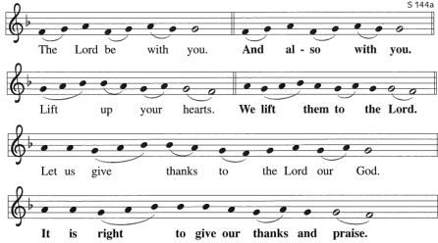

Great Thanksgiving (continued)
P: It is indeed right, our duty and our joy…we praise your name and join their unending hymn…

Holy, Holy, Holy
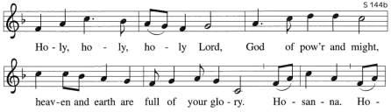
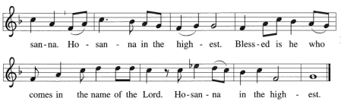
Words of Institution

The Lord’s Prayer

Our Father, who art in heaven, hallowed be thy name,
thy kingdom come, thy will be done, on earth as it is in
heaven. Give us this day our daily bread; and forgive us
our trespasses, as we forgive those who trespass against
us; and lead us not into temptation, but deliver us from
evil. For thine is the kingdom, and the power, and the
glory, forever and ever. Amen.

P: The gifts of God for the people of God. Taste and see that the Lord is good.
**Please note: Gluten-free wafers and white grape juice are available.

Communion Lamb of God

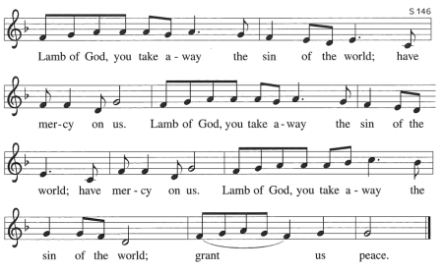
Communion Hymns

Wait for the Lord (Sung three times) ELW 262
The King Shall Come ELW260

Post-Communion Blessing

P: The body and blood of our Lord Jesus Christ strengthen you and keep you in his grace. C: Amen.

Post-Communion Canticle

Thankful Hearts
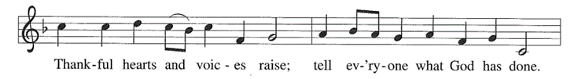
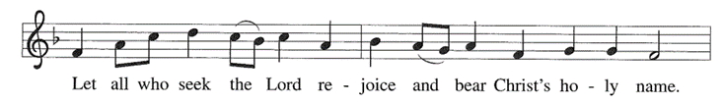
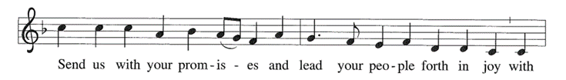

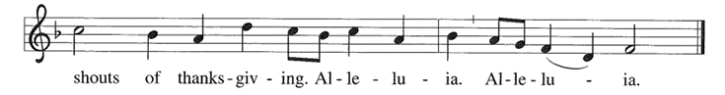

Prayer after Communion

A: Let us pray. Faithful God, in this meal you have remembered your mercy,
bringing heaven to earth in the body and blood of Christ. As we wait for the day when all your promises will be fulfilled, sustain us and strengthen us by this holy mystery. Guide us toward your promised future, coming to birth in Jesus Christ our Savior and Lord.
C: Amen.
SENDING
Blessing

P: God the eternal Word, who dwells with us in Jesus, and who holds us in the grace of the Holy Spirit, ☩ bless you now and forever. C: Amen.

Sending Song People, Look East ELW 248
Dismissal
A: Go in peace. Christ is near.
C: Thanks be to God.

12/11—Marjorie Whitney 12/15—Fran White
12/12—Garth Stowe 12/17—Marilyn Johns
12/12—Rachell Moyer

Building and Office Hours are: 9:00am – 2:30pm, Monday – Thursday.

Christmas Service Schedule: (All 3 Christmas Eve services will have Silent Night and Candlelight)
Christmas Eve – 4:00pm Worship Service with special emphasis on children
(service will be livestreamed)
Christmas Eve – 7:00pm Worship Service (service will not be livestreamed)
Christmas Eve – 9:00pm Holden Evening Prayer (service will not be livestreamed)
Christmas Day – 10:00am – Hymn Sing (service will not be livestreamed)
The Congregational 2023 Budget meeting will be after today’s service. Please stay for this important meeting.

Christmas Caroling Sunday, December 18th, after worship! This year we'd like to bring back the (pre-Covid) tradition of singing Christmas Carols to our homebound members. We can gear up on some hot chocolate and pizza/snacks beforehand at Bethlehem, grab the yummy wrapped cookies we'll be making at the December 8th Advent Night, and head out with Christmas songbooks in- hand. If you are interested, please let Pastor Paul or Nancy Ammann know or just show up that day in the Fellowship Hall some time shortly after 11:15am!

COVID: Please note that masks are required for unvaccinated persons in worship and highly encouraged for those who are vaccinated.

Today’s altar flowers are donated by: Julie Cole in Memory of Lyle & Marinan Bradford and Cal & Betty Cole

Pledges: As Bethlehem Lutheran Church prepares for a new year, it is important to know what support we can depend on from our congregation members. By knowing what you are willing to commit financially, we are able to better plan for the future. If you have already turned in your pledge card, we sincerely thank you. If you have not, please prayerfully consider doing so in the coming weeks. The “2023 open pledging season” will last through December 2022. Please be assured that we will happily accept your pledge at any time in 2023.
Jim Monroe, Financial Secretary, Phil Anderson, Bookkeeper
Refresh Update: Refresh is winding down this year. We have begun sanding and painting cabinets in our new Library/Conference Room. We hope to have the floor stripped and cleaned in the next few weeks along with some minor touch up items. We have also installed some new lighting in the gathering space. The new lights are LED and are brighter and provide a cleaner look to our gathering space. We do have some small items to finish up but most of our work in the gathering space will begin in 2023. Please let us know if you have any questions about our ongoing projects. Thanks to all who have made contributions and continue to support our work. Thanks, Chuck Ardingo
Third Thursday: The next Third Thursday service will be a service of Christmas Carols on December 15th at 7:00pm. The service will be livestreamed.

Advent is here, and we hope that you will join us for a meal before the Advent services on December 15. There will not be a meal before the December 22 activity.
Here is our menu:
December 15 – Sausage and Sauerkraut; also Cheese Pizza (Third Thursday/Hymn Sing - Will be Livestreamed)
December 22 – Blue Christmas “Winter Solstice Hike” (GT Commons Trail – meet by Spanglish Restaurant – will begin at 6:00pm)
At each meal we will also offer PBJ and bread, punch, water, coffee, and dessert.
The meal begins at 6:00 followed by the service at 7:00. Please note that Advent Services are on Thursday nights and should last approximately 30 minutes (no Communion). We hope to see you there!

Pecan Sale: The Worship and Music committee thanks you for your continued support during our annual Schermer Pecan sale. We also appreciate the seed money received from Thrivent again this year. We are sold out of the Dark Chocolate Pecans but we do have a limited supply of Caramel Clusters, Cinnamon Glazed, Milk Chocolates and Mammoth Halves. If you need more or did not get your pre-order in, please contact Barbara Oster at 231.668.7038 or beo6475@yahoo.com or call her at the BLC office (Monday, Tuesday or Thursday – 947.9880).

Prayer Requests:
• Prayer Chain: Please contact Jan Stretlien at jstretlien@gmail.com or 231-947-3265
• Prayers read from the altar: Please call Administrative Assistant in the church office 231-947-9880

Coffee and Cookies: You are welcome to stay after the service for coffee, cookies and conversation. This will be done as many Sundays as there are volunteers to make the coffee and/or bring cookies, etc. There is a sign-up sheet available near the cookies. There are open dates, so please sign up!

