Second Sunday in Lent
March 5, 2023 – 10am
Modern Worship, ELW Setting 4

Prelude Music

Announcements

Confession and Forgiveness
P: Blessed be the holy Trinity, ☩ one God, who journeys with us these forty days, and sustains us with the gift of grace.
C: Amen.

P: Let us acknowledge before God and one another our need for repentance and God’s mercy.

Silence is kept for reflection.

P: Holy God,
C: …we confess to you our faults and failings. Too often we neglect and do not trust your holy word; we take for ourselves instead of giving to others; we spoil rather than steward your creation; we cause hurt though you call us to heal; we choose fear over compassion. Forgive us, renew us, and lead us, as we seek to follow in your way of life. Amen.

P: Hear the good news: God so loved the world that God gave the only Son, so that all may receive life. This promise is for you! God embraces you with divine mercy, ☩ forgives you in Christ’s name, and revives you in the Spirit’s power.
C: Amen.

Gathering Song: Here I am to Worship

Light of the world, You stepped down into darkness, opened my eyes, let me see.
Beauty that made this heart adore You, hope of a life spent with You.

So, here I am to worship, here I am to bow down, here I am to say that You’re my God.
You’re altogether lovely, altogether worthy, altogether wonderful to me.

King of all days, oh so highly exalted, glorious in heaven above.
Humbly You came to the earth you created, all for love’s sake became poor.

So, here I am to worship, here I am to bow down, here I am to say that You’re my God.
You’re altogether lovely, altogether worthy, altogether wonderful to me.

And I’ll never know how much it cost to see my sin upon that cross.
And I’ll never know how much it cost to see my sin upon that cross.

So, here I am to worship, here I am to bow down, here I am to say that You’re my God.
You’re altogether lovely, altogether worthy, altogether wonderful to me.

Greeting

P: The grace of our Lord Jesus Christ, the love of God, and the communion of the Holy Spirit, be with you all!
C: And also with you!

Kyrie

A: In peace, let us pray to the Lord. C: Lord, have mercy.
A: For the peace from above, and for our salvation, let us pray to the Lord. C: Lord, have mercy.
A: For the peace of the whole world, for the well-being of the church of God, and for the unity of all, let us pray to the Lord. C: Lord, have mercy.
A: For this holy house, and for all who offer here their worship and praise, let us pray to the Lord.
C: Lord, have mercy.
A: Help, save, comfort, and defend us, gracious Lord. C: Amen.

Prayer of the Day

A: Let us pray together,
C: O God, our leader and guide, in the waters of baptism you bring us to new birth to live as your children. Strengthen our faith in your promises, that by your Spirit we may lift up your life to all the world through your Son, Jesus Christ, our Savior and Lord, who lives and reigns with you and the Holy Spirit, one God, now and forever. Amen.

Children’s Message Pr Paul

First Reading: Genesis 12:1-4a

God’s call of Abram and Sarai has a clear purpose—that through them all the families of the earth would gain a blessing. As they set out on their journey, they are accompanied by promises of land, nation, and a great reputation.

1 The Lord said to Abram, “Go from your country and your kindred and your father’s house to the land that I will show you. 2 I will make of you a great nation, and I will bless you, and make your name great, so that you will be a blessing. 3 I will bless those who bless you, and the one who curses you I will curse; and in you all the families of the earth shall be blessed.” 4a So Abram went, as the Lord had told him; and Lot went with him.

L: The Word of the Lord
C: Thanks be to God

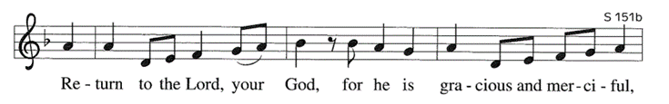
Gospel Acclamation: Return to the Lord

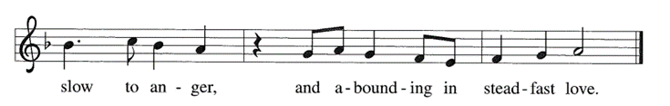

Gospel: John 3:1-17

A curious Pharisee visits Jesus by night to learn from the teacher his friends reject. Jesus speaks to him about life in the Spirit and the kingdom of God.

P: A reading from… C: Glory to You, O Lord.

1 Now there was a Pharisee named Nicodemus, a leader of the Jews. 2 He came to Jesus by night and said to him, “Rabbi, we know that you are a teacher who has come from God; for no one can do these signs that you do apart from the presence of God.” 3 Jesus answered him, “Very truly, I tell you, no one can see the kingdom of God without being born from above.” 4 Nicodemus said to him, “How can anyone be born after having grown old? Can one enter a second time into the mother’s womb and be born?” 5 Jesus answered, “Very truly, I tell you, no one can enter the kingdom of God without being born of water and Spirit. 6 What is born of the flesh is flesh, and what is born of the Spirit is spirit. 7 Do not be astonished that I said to you, ‘You must be born from above.’ 8 The wind blows where it chooses, and you hear the sound of it, but you do not know where it comes from or where it goes. So it is with everyone who is born of the Spirit.” 9 Nicodemus said to him, “How can these things be?” 10 Jesus answered him, “Are you a teacher of Israel, and yet you do not understand these things? 11 “Very truly, I tell you, we speak of what we know and testify to what we have seen; yet you do not receive our testimony. 12 If I have told you about earthly things and you do not believe, how can you believe if I tell you about heavenly things? 13 No one has ascended into heaven except the one who descended from heaven, the Son of Man. 14 And just as Moses lifted up the serpent in the wilderness, so must the Son of Man be lifted up, 15 that whoever believes in him may have eternal life. 16 “For God so loved the world that he gave his only Son, so that everyone who believes in him may not perish but may have eternal life. 17 “Indeed, God did not send the Son into the world to condemn the world, but in order that the world might be saved through him.”

P: The Gospel of the Lord.
C: Praise to you, O Christ.

Sermon Pastor Paul Busekist

Song of the Day: We Are Baptized in Christ Jesus ELW #451

Nicene Creed

We believe in one God, the Father, the Almighty, maker of heaven and earth, of all that is, seen and unseen.

We believe in one Lord, Jesus Christ, the only Son of God, eternally begotten of the Father, God from God, Light from Light, true God from true God, begotten, not made, of one Being with the Father; through him all things were made. For us and for our salvation he came down from heaven, was incarnate of the Holy Spirit and the virgin Mary and became truly human. For our sake he was crucified under Pontius Pilate; he suffered death and was buried. On the third day he rose again in accordance with the scriptures; he ascended into heaven and is seated at the right hand of the Father. He will come again in glory to judge the living and the dead, and his kingdom will have no end.

We believe in the Holy Spirit, the Lord, the giver of life, who proceeds from the Father and the Son, who with the Father and the Son is worshiped and glorified, who has spoken through the prophets. We believe in one holy catholic and apostolic church. We acknowledge one baptism for the forgiveness of sins. We look for the resurrection of the dead, and the life of the world to come. Amen.

Prayers of the Church / Sign of the Peace (Let us give one another a sign of peace according to your comfort level.)

Offering / Offering Song: Zeke Clemons

Offertory: Create in Me a Clean Heart
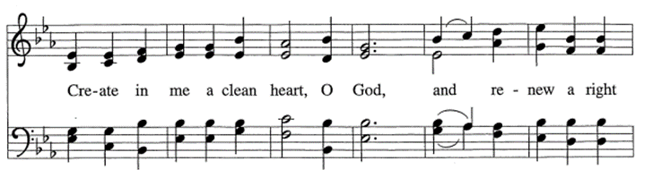

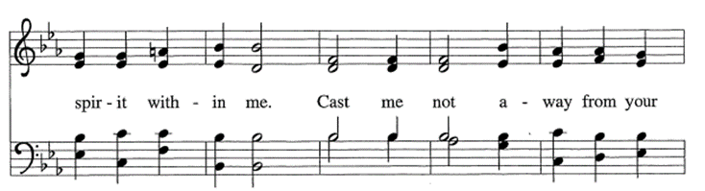
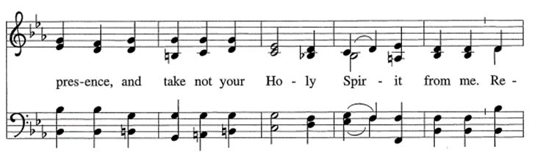
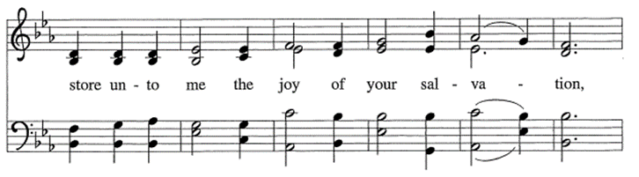

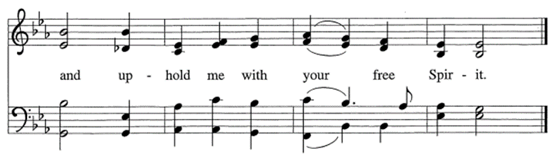

Offering Prayer

A: Let us pray.
C: God of good gifts, receive these and all our offerings as we present them in faithful service for the sake of your gospel. Prepare our hearts to receive you in this meal as you pour out your very presence through Christ Jesus, the wellspring of eternal life. Amen.

Words of Institution

Lord’s Prayer

Our Father, who art in heaven, hallowed be thy name, thy kingdom come, thy will be done,
on earth as it is in heaven. Give us this day our daily bread; and forgive us our trespasses,
as we forgive those who trespass against us; and lead us not into temptation, but deliver
us from evil. For thine is the kingdom, and the power, and the glory, forever and ever. Amen.

Communion (Please note: gluten-free wafers and white grape juice cups are available)

Communion Songs: Come and Taste BLC Choir
Lead Me, Guide Me ELW #767

Final Blessing

P: God, the giver of love, ☩ Christ, the resurrection and the life, and the Holy Spirit of rebirth bless you in this Lenten journey.
C: Amen.

Sending Song: How Firm a Foundation ELW #796

Dismissal

A: Go in peace. Serve in love.
C: Thanks be to God.

3/5—Joe Berry 3/7—Lisa Schlagel 3/12—Tom Christensen
3/5—Jodi Kelly 3/8—Corinne Hill
3/5—Cheryl Wegener 3/11—Laura Acker

This week’s Lenten service will be Taize “B” at 7:00pm on March 9th – it will not be livestreamed.

Building and Office Hours are: 9:00am – 2:30pm, Monday – Thursday.

Please Note:
Barbara Oster/Administrative Assistant works 9:00am-2:30pm on Monday, Tuesday and Thursday
Phil Anderson/Bookkeeper works 8:30am-12:30pm on Monday, Tuesday and Wednesday
Alanna Steffunick/Ministry Coordinator works 9:00am-2:30pm – in the office on Tuesday and Thursday and from home on Wednesday

UPDATE ON BABY PANTRY: March donations: laundry detergent and paper products. Note: Cleaning supplies cannot be purchased with food stamps, etc so there is a huge need for these items. There is also a need for food items. Anything you bring is most appreciated. Please bring items by today, March 5th, so they can be ready to distribute on March 9th when the Baby Pantry is open. Thank You!

DAYLIGHT SAVINGS TIME RETURNS/Spring Forward: Don’t forget to set your clocks ahead one hour on the morning of March 12th – next Sunday. We don’t want you to miss church.

Pledges: As Bethlehem Lutheran Church prepares for a new year, it is important to know what support we can depend on from our congregation members. By knowing what you are willing to commit financially, we are able to better plan for the future. If you have already turned in your pledge card, we sincerely thank you. If you have not, please prayerfully consider doing so in the coming weeks. Please be assured that we will happily accept your pledge at any time in 2023. Jim Monroe, Financial Secretary, Phil Anderson, Bookkeeper

IMPORTANT NOTICE: The giving envelopes have arrived! Please pick your box up in the Narthex. Phil Anderson, Bookkeeper

COVID: Please note that masks are required for unvaccinated persons in worship and highly encouraged for those who are vaccinated.

Offerings: The offering plates are now passed during the service. The vase in the back of the Sanctuary is still available for those who prefer not to touch the offering plate.

Third Thursday: The next Third Thursday service will be a Jazz Vespers service on March 16th at 7:00pm. The service will be livestreamed.

The March issue of the STAR is now available. For current issues of the Star, feel free to check online at www.bethlehemtc.org < About Us > “The Online Bethlehem Star” or type this URL to get these directly: http://www.bethlehemtc.org/the-bethlehem-star-newsletter.

Looking for a link to last month’s full Council minutes? Type this address/url into your web browser to get the latest approved minutes from Council: bethlehemtc.org/Council-Minutes OR you may call the office to request a copy.

Prayer Requests:
• Prayer Chain: Please contact Jan Stretlien at jstretlien@gmail.com or 231-947-3265
• Prayers read from the altar: Please call Administrative Assistant in the church office 231-947-9880

Celebrate a new child in your life with a rose on the baptismal font! Cost $10.00 per rose. Contact Barbara Oster at beo6475@yahoo.com or 231.668.7038.

Registration is now open for 2023 Summer Camp in New Era at Stony Lake - presented by Living Water Ministries. The website is https://elcalivingwater.com

Picture Directory: We have a chance to make a new directory this year, but with any project like this we need volunteers. Please leave your name in the office if you can help on this project in any way.

Choir announcement: The choir has some cool music planned for the Lent and Easter season. We will be rehearsing Tuesdays at 7:00 to accommodate Lenten mid-week services. Our next two rehearsals will be held on March 7, 14 and April 4. The choir will sing on Palm Sunday, Good Friday, and Easter Sunday. If you'd like to know more, talk to Tony Bero at a Thursday mid-week service or contact him at 231-942-1162, email: bero.tony@gmail.com.

Easter Flowers: See the insert with today’s bulletin to order your Easter flowers. Today is the deadline to order.

The season of Lent, and the promise of Easter are just around the corner. Lenten Thursdays will have:
6:00pm Meal: two soups, bread/rolls, a salad, dessert and beverages. There are still openings for the meals on March 9 and 16, if you would like to make a soup to share, or bring a side dish. There is a signup sheet in the Narthex with more information. Please give it a look. If you’d rather help in the kitchen, you would be most welcome! Please contact Laura Hahn with any questions: dandlhahn@gmail.com, 231-929-1339 (home), 231-499-1948 (cell) Thank you!
7:00pm Services - Only the March 16th Jazz Vespers will be LiveStreamed.
• March 9: Taize “B” (No Communion)
• March 16: Jazz Vespers with Communion
• March 23: Taize “A” (No Communion)
• March 30: Holden Evening Prayer (No Communion)
XYZ Potluck! Join us for good food, laughter and fellowship on Friday, March 10th at 12 Noon. While predominately geared toward seniors, we welcome any adult who would like to attend.

Sabbatical Team Update: Something to keep in mind. A ministry sabbatical is different from a traditional academic or business sabbatical. A pastor’s sabbatical is about the spirit and soul being refreshed, renewed, and redirected. The intent of a sabbatical, Sabbath, is a time to be silent and listen to God, not attend lectures or write papers. It is a time to be in solitude and to be with God, not “interact” with fatigued peers. If help is to be given to a pastor, it is not going to come by infusion of intellect, but by renewal of the spirit. Depending on what a pastor does while he is gone from his day to day pastoral duties, he will come back even more skilled and talented than when he left.

The synod assembly will be back in person this year instead of on-line. It will be held May 7-9 in Mt Pleasant. Immanuel/Bethlehem choir director Tony Bero will be leading the music. Our church is allowed to send one male and one female as voting members in addition to our pastor. Perhaps this is the year that you feel you are being called to do something new and different in your spiritual life? If so, please tell Pastor Paul or leave your name in the office.

The newest Living Lutheran magazine and the April/May/June Christ in Our Home can be picked up at the welcome table on Sunday mornings or from the Shooting STAR box below the outside mailbox

Are you looking for the Caring Table for your donations? It has been moved inside the coat room to the right.

Coffee and Cookies: You are welcome to stay after the Sunday service for coffee, cookies and conversation. This will be done as many Sundays as there are volunteers to make the coffee and/or bring cookies, etc. There is a sign-up sheet available near the cookies. There are open dates, so please sign up!

Name tags: Your name tags are back in your mailboxes. Please retrieve them so you can proudly wear them on Sunday mornings. We often have visitors and it helps them if they can see a friendly face and attach a name to it. If you notice a visitor, please encourage them to make a nametag which are kept with the welcome notebook.

Adult Bible Study gets together on Wednesdays from 9:30am-11:30am. It is a casual discussion of the Gospel of Luke. Bring your bibles and come, share, learn and grow with us.

The Zoom Bible Study: meets on Wednesdays from 1:30pm—3:00pm. This group will study the Book of Faith: Romans. Contact Pr Paul for Zoom information.

A big thank you to all who have turned in Oleson’s receipts. We just received a check from them for $186.58 for a grand total of $651.20 for the year 2022. Please continue to drop off your Oleson’s receipts at Bethlehem!!! Also note that they do not expire. Thank you so much!!!

Hoop’s Pet Food Pantry: This is the only pet food pantry in NW lower Michigan. They primarily provide dry food, wet food, treats, cat litter and toys for mostly dogs and cats but they will support any type of pet to the best of their ability. Please visit them at the Square Deal Country Store, 900 Woodmere Ave, TC from 1100am – 2:00pm on the 1st and 3rd Saturday of every month with your donations OR you may leave donations in the tub on our “donations” table in the coat room. The volunteers have expressed their appreciation when receiving our donations. Please note that they are anticipating an increased need over the winter.

2023 Relay for Life: The American Cancer Society will be holding their annual 24-Hour Relay for Life event on Saturday, June 10, 2023 starting at 10 AM with an opening ceremony to Sunday, June 11, 2023 ending at 10 AM at the Grand Traverse Mall. As a long-time volunteer with the organization, I would like to request your support in the form of monetary donations to the American Cancer Society in support of this great cause, which will impact so many wonderful people who need your help. Thank you very much for your generous donations in the past, which helped the American Cancer Society provide more programs and do more research and advocacy for cancer patients and their caregivers. Your kindness and thoughtfulness is really appreciated!

Have something important going on at Bethlehem that you'd like others to know about? Maybe a Small Group? A Club Event? Feature it on the Screen Announcements and on our Facebook Events Page! If there is something you'd like featured or included for either Screen Announcements or Facebook Events please reach out to alanna.steffunick@bethlehemtc.org

Please consider signing up for Altar Flowers for a Sunday service. Note that flowers are not placed on the altar during Lent (February 26th through April 2nd) and will resume on Easter Sunday. Please use the sign-up poster in the Narthex by signing on the date you request. Then fill out a pink slip with the necessary information and place it and a check for $40 (payable to Bethlehem Lutheran Church or BLC) in the offering plate on Sunday morning (Preferable) or during the week, in the Administrative Assistant’s mailbox near the church office entrance. You may select either “in honor” or “in memory” or “to celebrate”. If someone has already signed on the date you would like, feel free to add your name – we welcome more than one on a Sunday.

Bethlehem sends weekly emails directly to your inbox with important announcements and information!
If you are not getting them for any reason or if you have something you'd like to have added please reach out to alanna.steffunick@bethlehemtc.org

The church calendar is below. Please be sure to notify the office (admin@bethlehemtc.org or 231.947.9880) to be sure that your group is of the calendar.

Sunday, March 5
10:00am—Worship Service (S)
11:15am—Worship and Music Meeting (CR)
12:30pm—Confirmation (Offsite)

Monday, March 6
6:30pm—Sabbatical Meeting (Zoom)
7:00pm—All Star DE (FH)
Tuesday, March 7
Bulletin articles due today
9:00am—Property Work Group
9:00am—LWR Quilters (FH)
10:00am—Staff Meeting (CR)
5:00pm—All Star DE (FH)
7:00pm—Choir Rehearsal (S)

Wednesday, March 8
9:30am—Adult Bible Study (YR)
11:30am—Music Rehearsal (S)
1:30pm—Zoom Bible Study
7:00pm—All Star DE (FH)

Thursday, March 9
9:00am—Baby Pantry Set-up (FH)
10:00am—Baby Pantry (FH)
1:00pm—Rebecca Anna Circle
5:30pm—ACA
6:00pm—Lenten Dinner (FH)
7:00pm—Lenten Service/Taize “B” (S)
7:00pm—All Star DE (YR)

Friday, March 10
12:00pm—XYZ Potluck (FH)

Sunday, March 12
10:00am—Traditional Worship Service (S)

