Eighteenth Sunday after Pentecost
Bethlehem Lutheran Church
October 9, 2022 – 10 a.m.
Traditional Worship

Welcome to All! We are glad that you are able to worship with us today. Please fill out a connection card in the pews if you like. During the service, we will sit or stand in reverence to our Lord. Please do what is physically comfortable and reverent for you. For those who are unable to receive Communion near the altar and wish to have the Pastor administer it at your seat, please obtain a red and white card from one of the ushers and hold it up at Communion time to alert the Pastor. If you or a little one would like to receive a blessing instead of Holy Communion, we invite you to come forward and cross your arms at the time of Communion. Please feel free to introduce yourself to our Pastor and fill out one of the Visitor cards available at our Welcome Table in the Gathering Place.

Evangelical Lutheran Worship – Setting 3, page 138

Pre-Worship Music/Announcements/Temple Talk

Prelude

GATHERING

Confession and Forgiveness

P: Blessed be the holy Trinity, ☩ one God, who is eager to forgive and who loves us beyond our days. C: Amen.
P: Dear friends, together let us acknowledge our failure to love this world as Jesus does.
Silence is kept for reflection.
P: God of mercy and forgiveness,
C: …we confess that sin still has a hold on us. We have harmed your good creation. We have failed to do justice, love kindness, and walk humbly with you. Turn us in a new direction. Show us the path that leads to life. Be our refuge and strength on the journey, through Jesus Christ, our redeemer and friend. Amen.

P: Beloved of God: your sins are forgiven ☩ and you are made whole. God points the way to new life in Christ, who meets us on the road. Journey now in God’s abiding love through the power of the Holy Spirit. C: Amen.

Gathering Hymn O Word of God Incarnate ELW 514

Greeting

A: The grace of our Lord Jesus Christ, the love of God, and the communion of the Holy Spirit be with you all. C: And also with you.

Kyrie (lead by Leader)
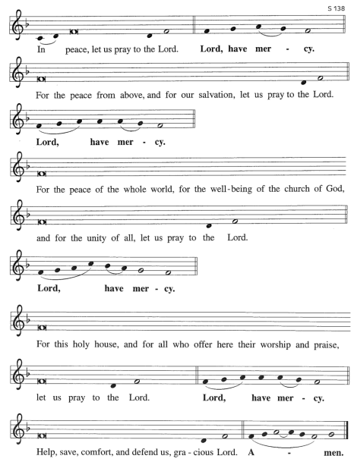

Hymn of Praise Glory to God
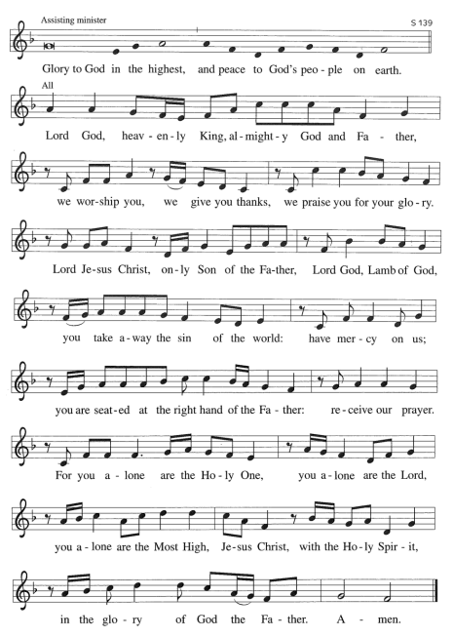

Prayer of the Day

A: Let us pray together…
C: Almighty and most merciful God, your bountiful goodness fills all creation. Keep us safe from all that may hurt us, that, whole and well in body and spirit, we may with grateful hearts accomplish all that you would have us do, through Jesus Christ, our Savior and Lord. Amen.

Children’s Message Annie Slabaugh

WORD

First Lesson 2 Kings 5:1-3, 7-15c
Naaman, a Syrian general, suffers from leprosy. In this passage Elisha miraculously cures his illness, but only after Naaman realizes, with the help of his servants, that he also needs healing for his pride. This foreign general then acknowledges the sovereignty of the God of Israel.

1Naaman, commander of the army of the king of Aram, was a great man and in high favor with his master, because by him the Lord had given victory to Aram. The man, though a mighty warrior, suffered from leprosy. 2Now the Arameans on one of their raids had taken a young girl captive from the land of Israel, and she served Naaman’s wife. 3She said to her mistress, “If only my lord were with the prophet who is in Samaria! He would cure him of his leprosy.” 7When the king of Israel read the letter, he tore his clothes and said, “Am I God, to give death or life, that this man sends word to me to cure a man of his leprosy? Just look and see how he is trying to pick a quarrel with me.” 8But when Elisha the man of God heard that the king of Israel had torn his clothes, he sent a message to the king, “Why have you torn your clothes? Let him come to me, that he may learn that there is a prophet in Israel.” 9So Naaman came with his horses and chariots, and halted at the entrance of Elisha’s house. 10Elisha sent a messenger to him, saying, “Go, wash in the Jordan seven times, and your flesh shall be restored and you shall be clean.” 11But Naaman became angry and went away, saying, “I thought that for me he would surely come out, and stand and call on the name of the Lord his God, and would wave his hand over the spot, and cure the leprosy! 12Are not Abana and Pharpar, the rivers of Damascus, better than all the waters of Israel? Could I not wash in them, and be clean?” He turned and went away in a rage. 13But his servants approached and said to him, “Father, if the prophet had commanded you to do something difficult, would you not have done it? How much more, when all he said to you was, ‘Wash, and be clean’?” 14So he went down and immersed himself seven times in the Jordan, according to the word of the man of God; his flesh was restored like the flesh of a young boy, and he was clean.
15a-cThen he returned to the man of God, he and all his company; he came and stood before him and said, “Now I know that there is no God in all the earth except in Israel.”

L: The Word of the Lord.
C: Thanks be to God.

Psalmody Psalm 111

1Hallelujah! I will give thanks to the Lord with my whole heart, in the assembly of the upright, in the congregation.
2Great are your works, O Lord, pondered by all who delight in them.

3Majesty and splendor mark your deeds, and your righteousness endures forever.
4You cause your wonders to be remembered; you are gracious and full of compassion.

5You give food to those who fear you, remembering forever your covenant.
6You have shown your people the power of your works in giving them the lands of the nations.

7The works of your hands are faithfulness and justice; all of your precepts are sure.
8They stand fast forever and ever, because they are done in truth and equity.

9You sent redemption to your people and commanded your covenant forever; holy and awesome is your name.
10The fear of the Lord is the beginning of wisdom; all who practice this have a good understanding. God’s praise endures forever.

Second Lesson 2 Timothy 2:8-15
Though Paul is chained as a prisoner, the word of God is never shackled or confined. Timothy is encouraged to proclaim that word of freedom in an honest and upright life as well as in his teaching and preaching.

8Remember Jesus Christ, raised from the dead, a descendant of David—that is my gospel, 9for which I suffer hardship, even to the point of being chained like a criminal. But the word of God is not chained. 10Therefore I endure everything for the sake of the elect, so that they may also obtain the salvation that is in Christ Jesus, with eternal glory. 11The saying is sure: If we have died with him, we will also live with him; 12if we endure, we will also reign with him; if we deny him, he will also deny us;
13if we are faithless, he remains faithful—for he cannot deny himself.

14Remind them of this, and warn them before God that they are to avoid wrangling over words, which does no good but only ruins those who are listening. 15Do your best to present yourself to God as one approved by him, a worker who has no need to be ashamed, rightly explaining the word of truth.

L: The Word of the Lord.
C: Thanks be to God.

Gospel Acclamation Alleluia

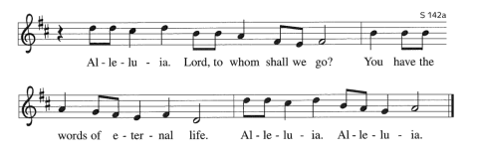

Gospel Luke 17:11-19

Jesus’ mission includes making people clean again. Unexpectedly, a Samaritan healed of leprosy becomes a model for those who would praise and worship God and give thanks for God’s mercy.

C: …Glory to you, O Lord…

11On the way to Jerusalem Jesus was going through the region between Samaria and Galilee. 12As he entered a village, ten lepers approached him. Keeping their distance, 13they called out, saying, “Jesus, Master, have mercy on us!” 14When he saw them, he said to them, “Go and show yourselves to the priests.” And as they went, they were made clean. 15Then one of them, when he saw that he was healed, turned back, praising God with a loud voice. 16He prostrated himself at Jesus’ feet and thanked him. And he was a Samaritan. 17Then Jesus asked, “Were not ten made clean? But the other nine, where are they? 18Was none of them found to return and give praise to God except this foreigner?” 19Then he said to him, “Get up and go on your way; your faith has made you well.”

P: The Gospel of the Lord.
C: Praise to you, O Christ.

Sermon Pastor Richard Anderson

Hymn of the Day The Church’s One Foundation ELW 654

Apostle’s Creed

I believe in God, the Father almighty, creator of heaven and earth.

I believe in Jesus Christ, God’s only Son, our Lord, who was conceived by the Holy Spirit, born of the virgin Mary, suffered under Pontius Pilate, was crucified, died, and was buried; he descended to the dead. On the third day he rose again; he ascended into heaven, he is seated at the right hand of the Father, and he will come to judge the living and the dead.

I believe in the Holy Spirit, the holy catholic church, the communion of saints, the forgiveness of sins, the resurrection of the body, and the life everlasting. Amen.

Prayers of Intercession: response after each petition: “Your mercy is great.” (Before prayer) A: In gratitude and humility, let us join together in prayer on behalf of all of God’s creation. (Conclusion) P: With grateful hearts we commend our spoken and silent prayers to you, O God; through Jesus Christ, our Lord. C: Amen.

Sharing of the Peace
P: The peace of Christ be with you always.
C: And also with you.
MEAL

Offering (Please be seated.)

Offering Song: Zeke Clemons

Offertory (Please stand, as able.) Let the Vineyards Be Fruitful
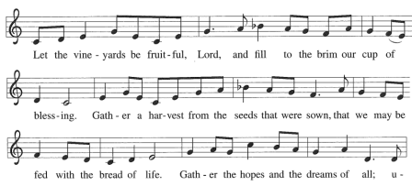
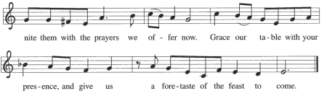
Offering Prayer

A: Let us pray.
C: Gracious God, in your great love you richly provide for our needs.
Make of these gifts a banquet of blessing, and make us ready to share with all in need; through Jesus Christ, who sets a table for all.
Amen.

Great Thanksgiving
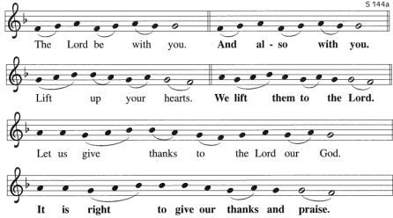

Great Thanksgiving (continued)
P: It is indeed right, our duty and our joy…we praise your name and join their unending hymn…

Holy, Holy, Holy
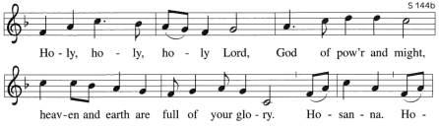
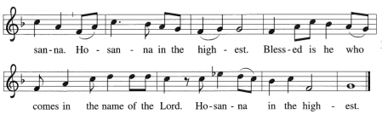

Words of Institution

The Lord’s Prayer

Our Father, who art in heaven, hallowed be thy name,
thy kingdom come, thy will be done, on earth as it is in
heaven. Give us this day our daily bread; and forgive us
our trespasses, as we forgive those who trespass against
us; and lead us not into temptation, but deliver us from
evil. For thine is the kingdom, and the power, and the
glory, forever and ever. Amen.

P: The gifts of God for the people of God. Taste and see that the Lord is good.

**Please note: Gluten-free wafers and white grape juice are available.

Communion Lamb of God

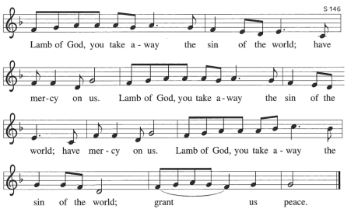

Communion Hymns

Now All the Vault of Heaven Resounds ELW 367
Alleluia! Jesus Is Risen ELW 377

Post-Communion Blessing

P: The body and blood of our Lord Jesus Christ strengthen you and keep you in his grace. C: Amen.

Post-Communion Canticle

Thankful Hearts
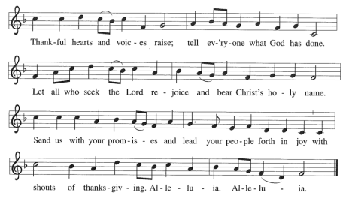
Prayer after Communion

A: Let us pray. God of the abundant table, you have refreshed our hearts in this meal with bread for the journey. Give us your grace on the road that we might serve our neighbors with joy; for the sake of Jesus Christ, our Lord.
C: Amen.

SENDING
Blessing

P: God, who gives life to all things and frees us from despair, bless you with truth and peace. And may the holy Trinity, ☩ one God, guide you always in faith, hope, and love.
C: Amen.

Sending Song I Love to Tell the Story ELW 661

Dismissal A: Go in peace, with Christ beside you C: Thanks be to God

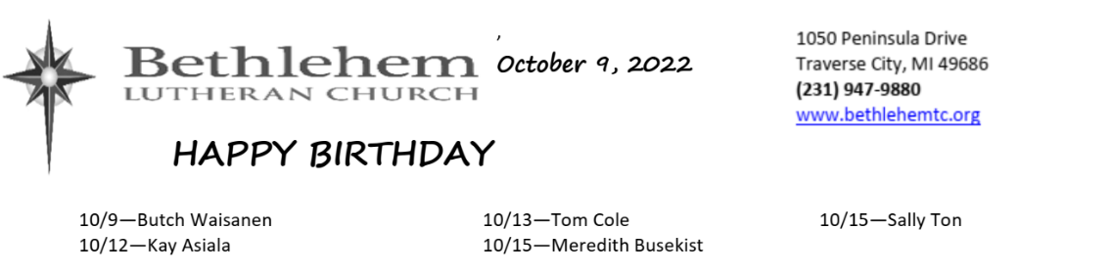
We welcome Pastor Richard Anderson as our Presiding and Preaching Minister today.

Building and Office Hours are: 9:00am – 2:30pm, Monday – Thursday.

The Refresh Committee: We have reached our Goal of $10,000 and we Thank Everyone who supported Our Refresh Project. If you have not contributed and still wish to, we appreciate any additional contributions to further our Refresh efforts. You can make a contribution and place it in the collection plate (Write Refresh on your check) or see Phil Anderson in the church office.

COVID: Please note that masks are required for unvaccinated persons in worship and highly encouraged for those who are vaccinated.

Today’s altar flowers are donated by: the Congregation in thanks for all of God’s blessings.

Offerings: The offering plates are now passed during the service. The vase in the back of the Sanctuary is still available for those who prefer not to touch the offering plate.

Third Thursday: The next Third Thursday service will be a Taize service on October 20th at 7:00pm. The service will be livestreamed.

The October issue of the STAR is now available. For current issues of the Star, feel free to check online at www.bethlehemtc.org < About Us > “The Online Bethlehem Star” or type this URL to get these directly: http://www.bethlehemtc.org/the-bethlehem-star-newsletter.

Looking for a link to last month’s full Council minutes? Type this address/url into your web browser to get the latest approved minutes from Council: bethlehemtc.org/Council-Minutes OR you may call the office to request a copy.

Prayer Requests:
• Prayer Chain: Please contact Jan Stretlien at jstretlien@gmail.com or 231-947-3265
• Prayers read from the altar: Please call Administrative Assistant in the church office 231-947-9880

Celebrate a new child in your life with a rose on the baptismal font! Cost $10.00 per rose. Contact Barbara Oster in the church office or admin@bethlehemtc.org.

We will be having a send off celebration for Annie, Trent and Caleb on October 23rd after church. There will be cake, punch and coffee in the Fellowship Hall. Members of the congregation may like to give them a card with your personal well wishes.

The newest Living Lutheran magazine and the October/November/December Christ in Our Home can be picked up at the welcome table on Sunday mornings, from the Shooting STAR box below the outside mailbox, or during parking lot communion.

XYZ Potluck has returned! Join us for good food, laughter and fellowship on Friday, October 14th at 12 Noon. For now it will be mainly fellowship but we plan to eventually add a program. While predominately geared toward seniors, we welcome any adult who would like to attend.

Hallelujah! We are indeed blessed here at Bethlehem. It is with great excitement that Council will be voting this month to approve our new Administrative Assistant - Barbara Oster. Barbara will be working Monday, Tuesday, and Thursday during normal church office hours. Kate Holtfreter has agreed to cover the office on Wednesday afternoons while she completes her volunteer duties.

HELP NEEDED: We are looking for volunteers for our A/V Team – specifically to advance the PowerPoint slides and/or pressing the button to change the angle for the Livestream camera. You don’t need to be proficient on computers, just able to follow the service and press a button. Training will be available. Contact Barbara Oster if you are interested. If you would like to watch the procedure on a Sunday, that can be arranged.

Coffee and Cookies: You are welcome to stay after the service for coffee, cookies and conversation. This will be done as many Sundays as there are volunteers to make the coffee and/or bring cookies, etc. There is a sign-up sheet available near the cookies. There are open dates, so please sign up!

Name tags: Your name tags are back in your mailboxes. Please walk a little farther and retrieve them so you can proudly wear them on Sunday mornings. We often have visitors and it helps them if they can see a friendly face and attach a name to it.

Choir announcement: IT’S BACK!! The choir will be singing during the service today. Come add some music into your life! Rehearsals are 2-3 Thursdays per month at 7:00. The next rehearsal is Thursday, October 13th. Contact Tony Bero at bero.tony@gmail.com or 942-1162.

