**Twenty-Fifth Sunday after Pentecost**

**WELCA Thank Offering Sunday**

**Bethlehem Lutheran Church**

**November 10, 2024**

**Sunday 10:00 a.m.**

**Welcome to All!** We are glad that you are able to worship with us today. **Please fill out a connection card in the pews if you like.** During the service, we will sit or stand in reverence to our Lord. Please do what is physically comfortable and reverent for you. For those who are unable to receive Communion near the altar and wish to have the Pastor administer it at your seat, please obtain a red and white card from one of the ushers and hold it up at Communion time to alert the Pastor. If you or a little one would like to receive a blessing instead of Holy Communion, we invite you to come forward and cross your arms at the time of Communion. Please feel free to introduce yourself to our Pastor and fill out one of the Visitor cards available at our Welcome Table in the Gathering Place.

**Evangelical Lutheran Worship – Setting 4, page 147**

**Pre-Worship Music/Welcome/Announcements**

**Prelude *We Are the Church Avery and Marsh***

*(see insert)*

**GATHERING**

**Thanksgiving for Baptism**

P: Blessed be the triune + God, who pours out love, justice, and mercy

in abundance.

**C: Amen.**

P: Joined by water to Christ and to creation, let us give thanks for the gift of baptism.

P: For all gifts of water,

**C: we give you thanks, O God.**

P: For rivers and lakes, for streams and oceans, for healing rains and clean water to drink:

**C: we give you thanks, O God.**

P: For Miriam’s song of liberation on the far bank of the sea,

For Isaiah’s invitation to “come and drink, without money and without price,”

For Jesus’s baptism and commissioning in the waters of the Jordan,

*(continued on next page)*

For the Samaritan woman, revived by living water,

For your holy river that waters the tree of life:

**C: we give you thanks, O God.**

P: For the outpouring of the Holy Spirit,

For baptismal waters,

For the cleansing of our hearts,

For the refreshment of our spirits,

For waves of mercy,

For justice, rolling like rivers:

**C: we give you thanks, O God.**

P: Blessing, honor, and glory be to you, O God, and eternal gratitude for all your good gifts. **C: Amen**.

**Gathering Hymn** ***Praise and Thanksgiving Be to God ELW #458***

**Greeting**

A: The grace of our Lord Jesus Christ, the love of God, and the communion of the Holy Spirit be with you all. **C: And also with you.**

**Kyrie**

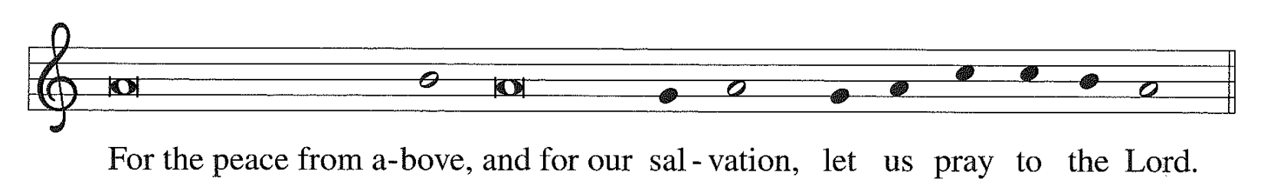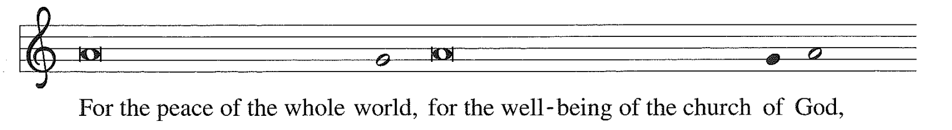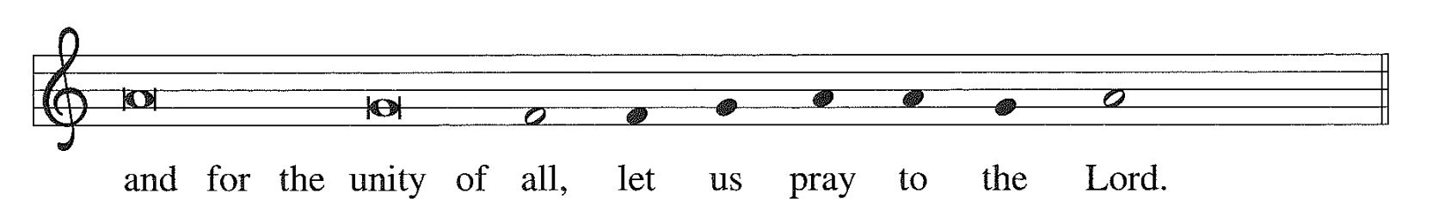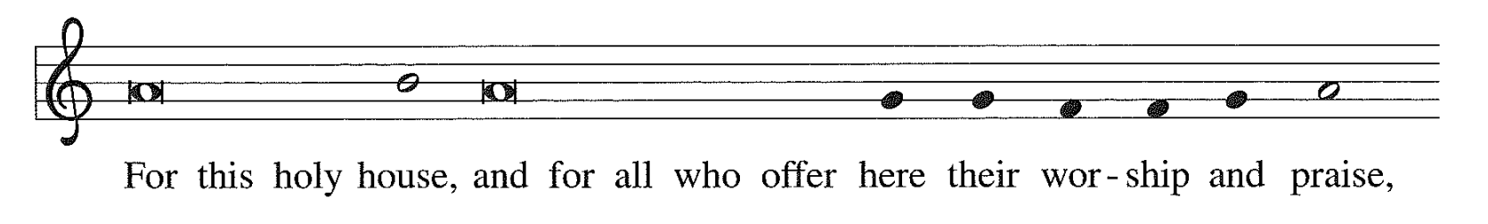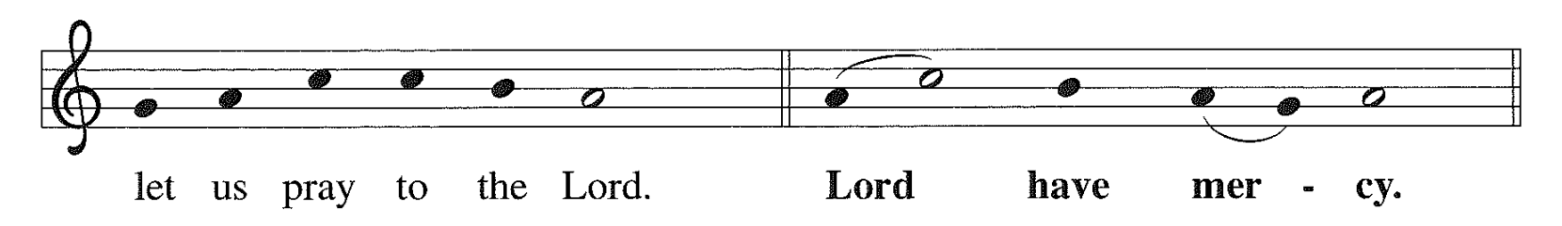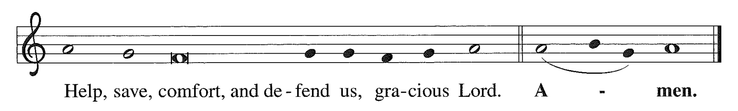

**Hymn of Praise *Glory to God***

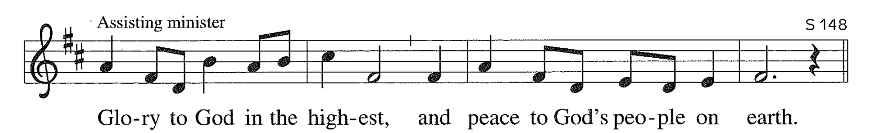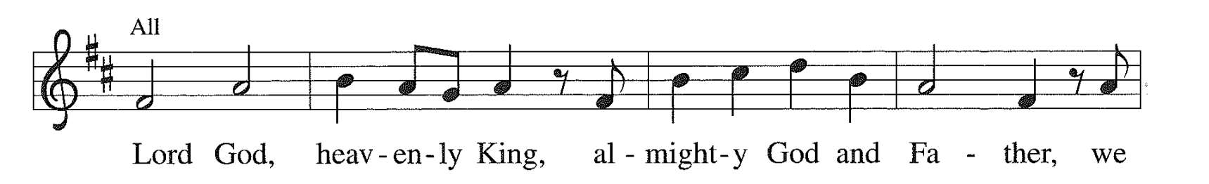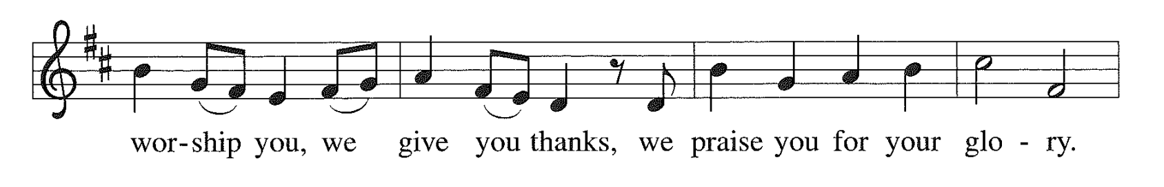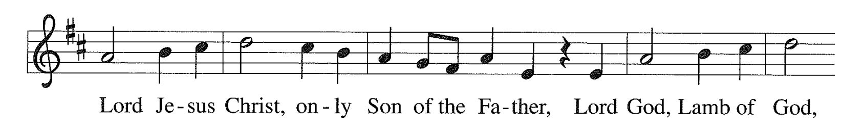

*(continued on next page)*

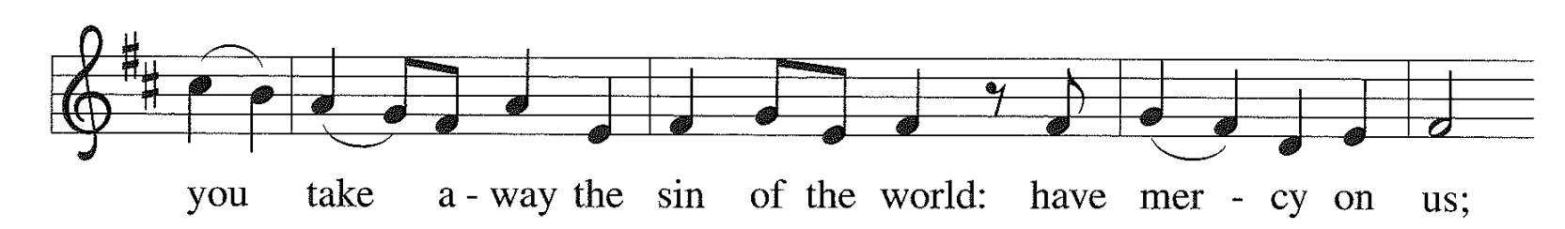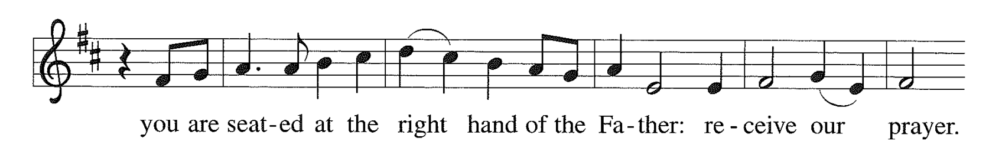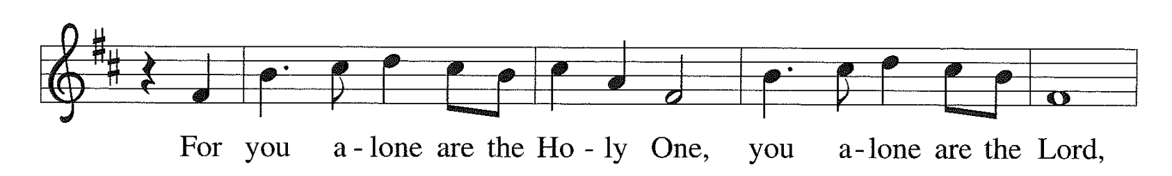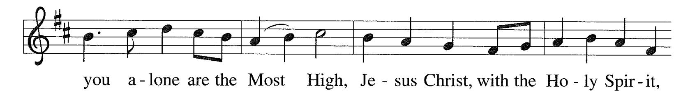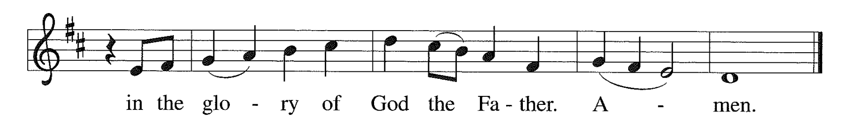

**Prayer of the Day**

A: The Lord be with you. **C: And also with you.**

A: Let us pray together… **C:** **God of abundance, We give thanks every time we remember your goodness. Teach us to respond to your love with faithfulness and generosity. Keep us mindful of your blessings, and especially the blessing of wholeness and salvation that you offer us through the life, death, and resurrection of Jesus Christ, our savior. Amen.**

**Temple Talk – WELCA Thank Offering**

**WORD**

**First Lesson** **1 Kings 17:8-16**

*This chapter begins the story of Elijah. God sends a drought on Israel because of the sins of King Ahab. This passage depicts God’s saving acts not only on behalf of Elijah, but also on behalf of those who are associated with the prophet, even a foreigner, the widow of Zarephath.*

8 The word of the Lord came to Elijah, saying, 9 “Go now to Zarephath, which belongs to Sidon, and live there; for I have commanded a widow there to feed you.” 10 So he set out and went to Zarephath. When he came to the gate of the town, a widow was there gathering sticks; he called to her and said, “Bring me a little water in a vessel, so that I may drink.” 11 As she was going to bring it, he called to her and said, “Bring me a morsel of bread in your hand.” 12 But she said, “As the Lord your God lives, I have nothing baked, only a handful of meal in a jar, and a little oil in a jug; I am now gathering a couple of sticks, so that I may go home and prepare it for myself and my son, that we may eat it, and die.” 13 Elijah said to her, “Do not be afraid; go and do as you have said; but first make me a little cake of it and bring it to me, and afterwards make something for yourself and your son. 14 For thus says the Lord the God of Israel: The jar of meal will not be emptied and the jug of oil will not fail until the day that the Lord sends rain on the earth.” 15 She went and did as Elijah said, so that she as well as he and her household ate for many days. 16 The jar of meal was not emptied, neither did the jug of oil fail, according to the word of the Lord that he spoke by Elijah.

L: The Word of the Lord.

**C: Thanks be to God.**

**Psalmody Psalm** **107: 1-9, 43**

1 O give thanks to the Lord, for he is good; for his steadfast love endures forever.

**2 Let the redeemed of the Lord say so, those he redeemed from trouble**

3 and gathered in from the lands, from the east and from the west, from the north and from the south.

**4 Some wandered in desert wastes, finding no way to an inhabited town;**

5 hungry and thirsty, their soul fainted within them.

**6 Then they cried to the Lord in their trouble, and he delivered them from their distress;**

7 he led them by a straight way, until they reached an inhabited town.

**8 Let them thank the Lord for his steadfast love, for his wonderful works to humankind.**

43 Let those who are wise give heed to these things, and consider the steadfast love of the Lord.

**Second Lesson** **Philippians 1:3-11**

3 I thank my God every time I remember you, 4 constantly praying with joy in every one of my prayers for all of you, 5 because of your sharing in the gospel from the first day until now. 6 I am confident of this, that the one who began a good work among you will bring it to completion by the day of Jesus Christ. 7 It is right for me to think this way about all of you, because you hold me in your heart, for all of you share in God’s grace with me,

*(continued on next page)*

both in my imprisonment and in the defence and confirmation of the gospel. 8 For God is my witness, how I long for all of you with the compassion of Christ Jesus. 9 And this is my prayer, that your love may overflow more and more with knowledge and full insight 10 to help you to determine what is best, so that on the day of Christ you may be pure and blameless, 11 having produced the harvest of righteousness that comes through Jesus Christ for the glory and praise of God.

L: The Word of the Lord.

**C: Thanks be to God.**

**Gospel Acclamation *Alleluia***

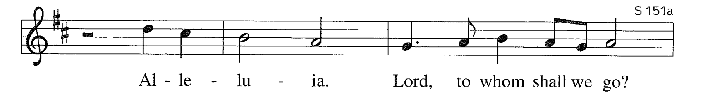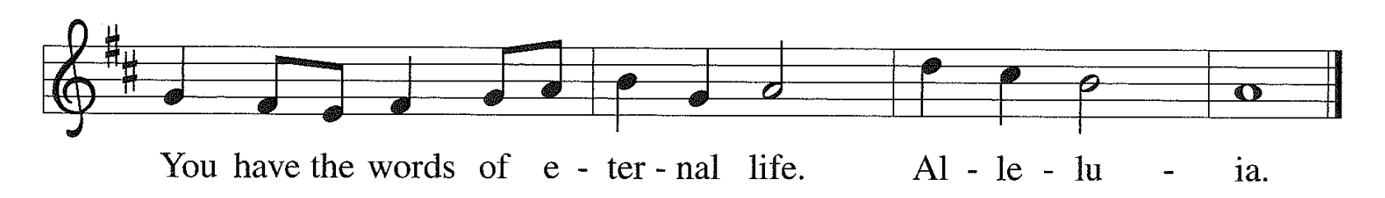

**Gospel** **Mark 12:38-44**

*After engaging in a series of public arguments with religious leaders in the temple, Jesus contrasts the proud and oppressive ways of those leaders with the sacrificial humility and poverty of the widow.*

**C: …Glory to you, O Lord…**

38 As Jesus taught, he said, “Beware of the scribes, who like to walk around in long robes, and to be greeted with respect in the marketplaces, 39 and to have the best seats in the synagogues and places of honor at banquets! 40 They devour widows’ houses and for the sake of appearance say long prayers. They will receive the greater condemnation.” 41 He sat down opposite the treasury, and watched the crowd putting money into the treasury. Many rich people put in large sums. 42 A poor widow came and put in two small copper coins, which are worth a penny. 43 Then he called his disciples and said to them, “Truly I tell you, this poor widow has put in more than all those who are contributing to the treasury. 44 For all of them have contributed out of their abundance; but she out of her poverty has put in everything she had, all she had to live on.”

P: The Gospel of the Lord.

**C: Praise to you, O Christ.**

**Sermon Sherri Helman**

**Hymn of the Day** ***Let All Things Now Living ELW #881***

**Apostle’s Creed**

**I believe in God, the Father almighty, creator of heaven and earth.**

**I believe in Jesus Christ, God’s only Son, our Lord, who was conceived by the Holy Spirit, born of the virgin Mary, suffered under Pontius Pilate, was crucified, died, and was buried; he descended to the dead. On the third day he rose again; he ascended into heaven, he is seated at the right hand of the Father, and he will come to judge the living and the dead.**

**I believe in the Holy Spirit, the holy catholic church, the communion of saints, the forgiveness of sins, the resurrection of the body, and the life everlasting. Amen.**

**Prayers of Intercession:** response after each petition: **“receive our prayer.”** *(Before prayer)* A: With gratitude to God, we remember in prayer our church, our neighbors, and our world.… *(Conclusion)* P: Into your hands, gracious God, we commend all that for which we pray, trusting in your mercy, given for us and for all, in the name of Jesus Christ our Lord. **C: Amen.**

**Sharing of the Peace**

P: The peace of Christ be with you always.

**C: And also with you.**

**MEAL**

**Offering** ***We Raise Our Hands to You, O Lord ELW #690***

*(Verses 1, 3 & 5)*

**Offertory  *As the Grains of Wheat ELW #465***

**Offering Prayer**

A: Let us pray. **C:** **Gracious God, We give thanks each time we remember you and your blessings. Receive what we have offered now: our gifts, our time, and our whole selves. Bless our thank offerings and the work of Women of the ELCA that these offerings make possible. Make us good and faithful stewards of your gifts, that all people know the bounty of your love. We pray in the name of Christ, Amen.**

**Great Thanksgiving**

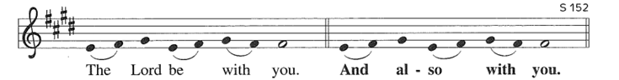

*(continued on next page)*

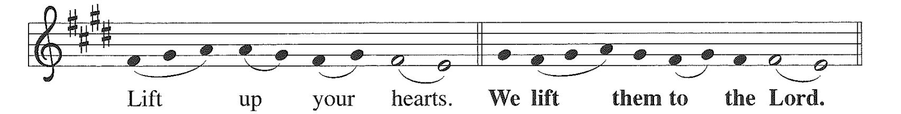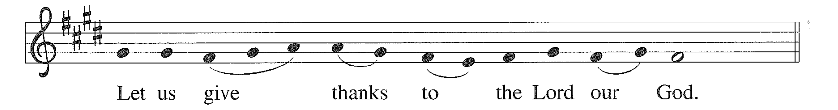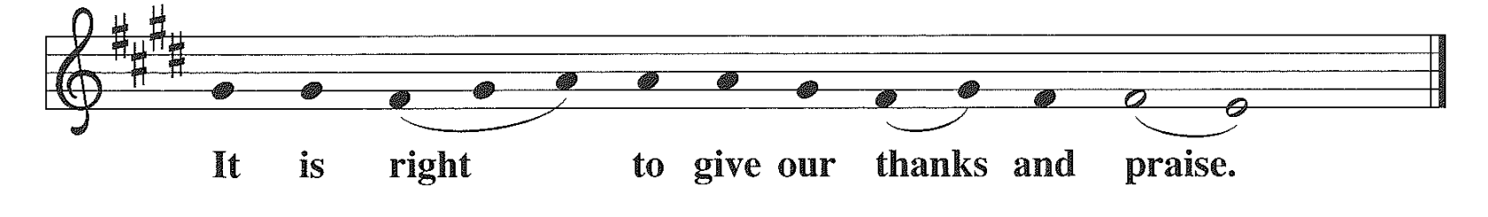

P: It is indeed right, our duty and our joy…we praise your name and join their unending hymn…

***Holy, Holy, Holy***

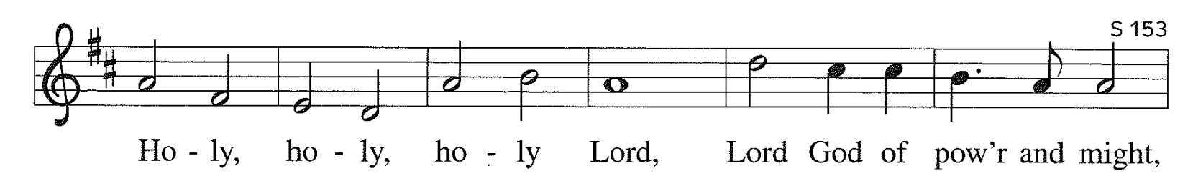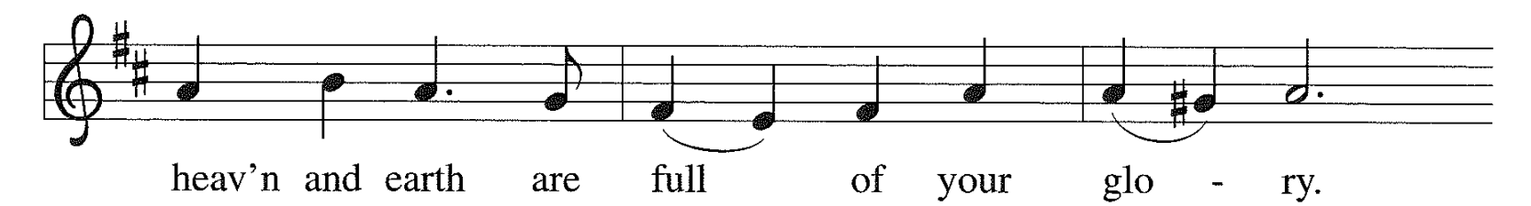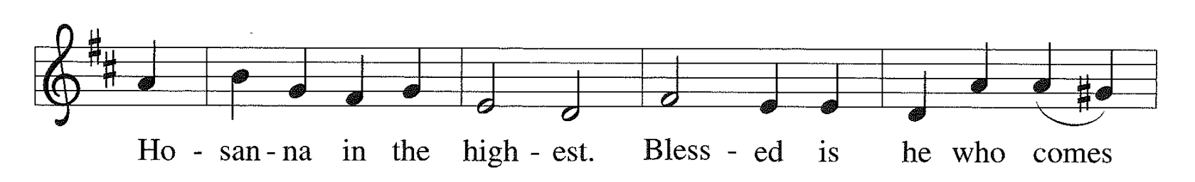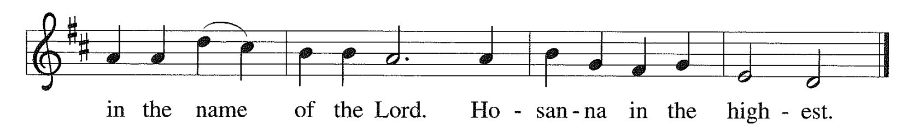

**Words of Institution**

**The Lord’s Prayer**

**Our Father, who art in heaven, hallowed be thy name,**

**thy kingdom come, thy will be done, on earth as it is in**

**heaven. Give us this day our daily bread; and forgive us**

**our trespasses, as we forgive those who trespass against**

**us; and lead us not into temptation, but deliver us from**

**evil. For thine is the kingdom, and the power, and the**

**glory, forever and ever. Amen.**

P: The gifts of God for the people of God. Taste and see that the Lord is good.

**Communion *Lamb of God***

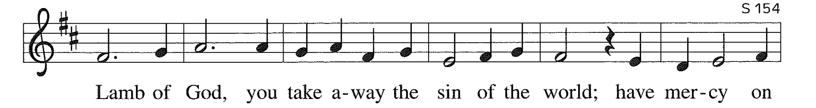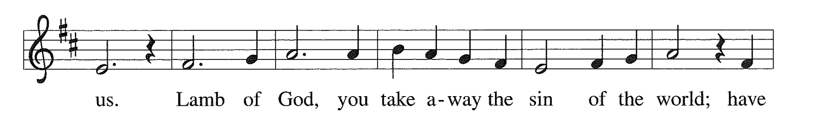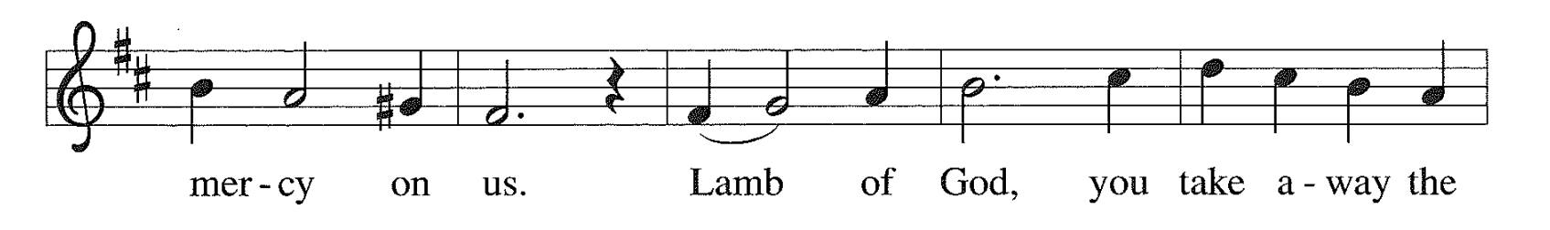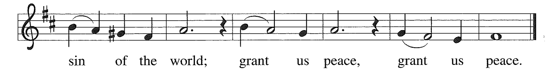

**Communion Hymns**

***Blessed Assurance ELW #638***

***Let Us Talents and Tongues Employ ELW #674***

**Post-Communion Blessing**

P: The body and blood of our Lord Jesus Christ strengthen you and keep you in his grace. **C: Amen.**

**Post-Communion Canticle**

***Thankful Hearts***

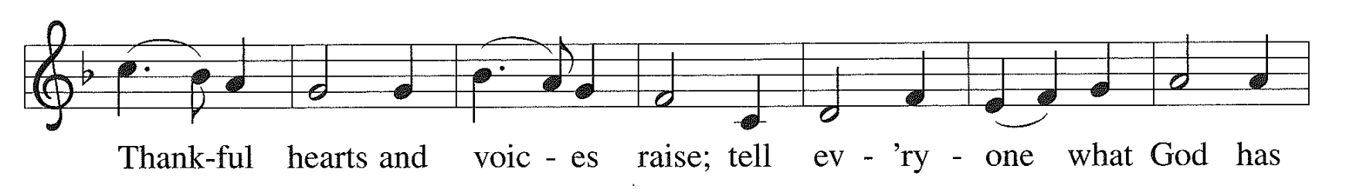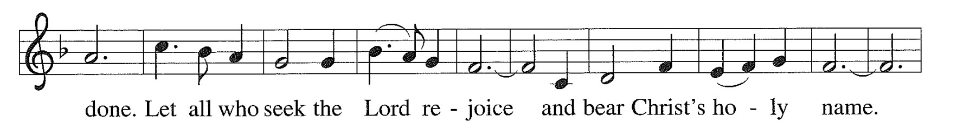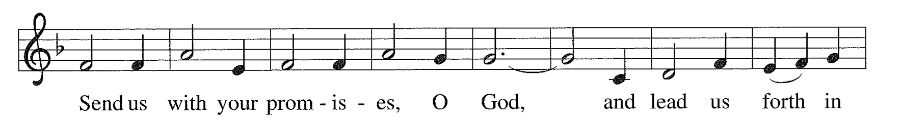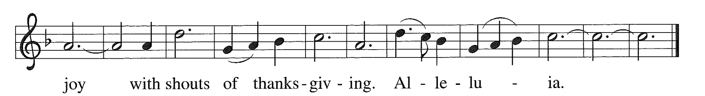

**Prayer after Communion**

A: Let us pray. Holy God, You have provided for us a feast of life. We are nourished and we are grateful. Strengthen us through this meal and send us out to provide for others, following the example of Jesus Christ, our savior and Lord. **C: Amen.**

**SENDING**

**Blessing**

P: God has filled the hungry and thirsty with good things:

**C: Let us give thanks to God, for God’s mercy endures forever!**

P: God has done wonderful works for all people:

**C: Let us rejoice in God’s steadfast love!**

P: God has looked upon us with grace and favor:

**C: Let us remember God’s mercy!**

P: God has put into our hearts a song of thanksgiving and freedom:

**C: Let us join our voices in singing our praise!**

P: The God of abundance, Creator, + Redeemer, and Spirit, bless you and keep you, now and forever.

**C: Amen.**

**Sending Song** ***Now Thank We All Our God ELW #840***

**Dismissal**

A: Go in peace. Live with gratitude.

**C: Thanks be to God.**

**“We journey with God**

**to serve with love.”**



11/15—Marilyn Halstead 11/16—Patty Leibenguth

**Worship Servants for November 10**

Assisting Minister—Barbara Wright

Lector—Barb Graf

Musicians: David Husser, Phil & Denice Bossardet, Pr. Paul

Today’s altar flowers are donated: *By WELCA in Celebration of Women of Bethlehem*

*By Norm & Jane Fred in Celebration of the 17th Birthday of granddaughter Evelyn Aubrey Martel today*

Hospitality—Nancy Ammann / Barb Graf

A/V— Paul Ton / Jim Hinds / Acker Family

Cookies/Coffee— WELCA / Mary Ann Tanis

Welcome Table— Gail Goldsmith

Bell Ringer— Gail Goldsmith

Front Door Monitors—Jana / Tom Rockne

Altar Guild—Barbara Oster

Tech Support—Julia Acker

Counters—Laura Hahn / John Halstead

**Visioning Conversations in our BLC Community:** Today, we will spend some time in the afternoon visiting residents in our BLC neighborhood. This is part of the “Listening for God in the Community” segment as we prepare for our next meeting on Sunday, November 17. If you are willing and interested in joining these door-to-door conversations, please join Pastor Paul and Sherri at the church, today, November 10, at 2:15 p.m. We will go over the format as we gather and prepare to go out 2 by 2. Even an hour of your time will be of great benefit as we continue our Vision work together. Hope to see you there!

**JOIN THE VISION TRAIN….Time to take a PAUSE!!** We are now at the point in our journey when we have a few weeks off from our Sunday events. Time to continue to pray and ponder what God has in store for us. We are making great progress. Community teams are reaching out to leaders in our larger neighborhoods to gain additional information about the needs in Traverse City. **More will be shared next Sunday, November 17.**  Please make every effort to attend this last conversation and let us know of your plans by signing up on the display in the narthex. Thank you for being here as often as possible. It takes all of us to share in the work of the Kingdom.

**The Worship and Music committee’s Pecan Sale**. The cases have been ordered and hopefully will be delivered some time in November. We will have a few bags left to sell for those who did not order. As in the past, we truly appreciate the support of Thrivent in this fundraiser. Hopefully, delivery should be in the next couple of weeks

**Giving Statements Available**: Your individual giving statements will be available in your mailbox in the Narthex beginning Sunday November 3, 2024. The statement covers giving from January 1st through September 30th. Please pick them up at your convenience. To save on postage, I will mail out the ones not picked up by the end of November. Thank you for your generous support for the programs and ministries of your church. We are all blessed by your faithful giving. Your Bookkeeper

**CHANGE OF DAYS FOR BOOK CLUB**: After years of meeting on Tuesdays the Book Club has moved our meetings to the **3rd WEDNESDAY of the month. The next meeting will be Wed, Nov 20 at 5:30.** We are reading “James”. This is the story of the Adventures of Huckleberry Finn told from the point of view of the enslaved Jim. It is a Best Book of the Year for 2024 and a feature film of the book by Steven Spielberg is in development. Please join us in the Fellowship Hall if you like to discuss good books. Any questions can be directed to Cindy Monroe at cmonroe@chartermi.net.

**BOOK OF RECIPES PRESENTED TO ALANNA IN HONOR OF HER MARRIAGE TO JOSH BOOMER**: Congratulation and best wishes to Alanna and Josh Boomer who were united in marriage on Oct 26 and celebrated in the way most meaningful to them with a Contra Dance Reception. If you missed your chance to contribute your favorite family recipe or a recipe for a happy marriage to the book already presented to Alanna, you can place one in Alanna’s mailbox at any time.

**CHOIR NEWS**: Choir rehearsals have resumed on **Thursdays at 7:00 –November 14.** More dates are being discussed so look for those in upcoming bulletins. If you are interested in joining the choir, give your contact information to Cindy Monroe or any member of the choir and have them pass it on to our choir director, Tony Bero and he will get in touch with you directly. Or you can simply arrive at choir rehearsal on Thursday and we'll figure out how best to use your talents.

**Third Thursday Worship Service and Meal**: Bethlehem’s next Third Thursday Worship Service and meal will be on November 21st. The meal will begin at 5:45 and the Fellowship Committee will be providing Cobb salad, dessert and beverages. Please come and enjoy a meal and social time before the Taize 1 service which begins at 7:00pm